Year: 2013 - 2014

Group 1

Geothermal Energy:

An innovative energy for the future ?

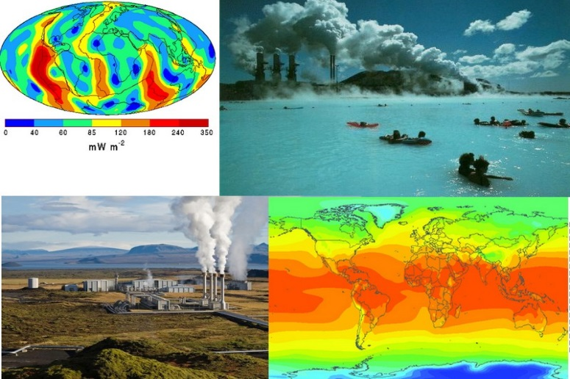

From Paul BOUVET to Alicja Bailly

March 2014

Executive summary:

I) Introduction 3

II) Geothermal energy : Global presentation 4

III) Different kinds of process in order to obtain geothermal energy 5

IV) Advantages and disadvantages of geothermal energy 8

V) Conclusion 10

VI) Bibliography and sources 11

1. Introduction

*The aim of this report is to outline the general characteristics of geothermal in order to bring out in what this phenomenon can be a natural solution to create thermic energy and thus to answer to the increase of thermal and energetic needs for the future. To explain all of the details of this energy, this study will be divide into three parts in which it will be set forth: a general presentation of geothermal energy, the different kinds of process to obtain it and finally the advantages and the disadvantages of its utilisation.*

1. Geothermal energy : Global presentation

Geothermal energy is an energy which is present everywhere on the world. Indeed, below the earth’s crust, an important layer of molten rock is continually cranked out every day. This layer called magma is the result of the decay of naturally radioactive material (potassium, thorium, uranium) into the earth’s crust. Thanks to this phenomenon an important quantity of heat will be produced, this one will be defined as geothermal gradient.[1]

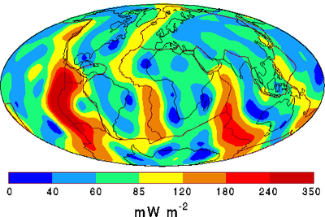[2]This gradient, measured in mW.m2, is present on different proportion in all of the earth. Another remark is important to detail: An augmentation of this gradient and thus the temperature will be noticed as the earth is digged. That is to say that the temperature will be hotter in depth than on the surface.   
  
On average an augmentation of 30°C per 100Km will be noticed. Nonetheless in spite of theses observation, the heat is divided in different proportions on the earth’s surface.

The map above is revealing the disposition of the heat observed in all of the Earth. An important quantity is present on America’s continent (about 350 mW.m2 and a significant part (between 85 and 120 mW.m2) is also noticeable on the west of Africa and the Est of Asian’s continent. Thereby with consideration of this map, geothermal energy is appeared as an energy present everywhere and especially present in a big quantity in the depths of countries with a high energetic demand such as at United states or at Japan. Furthermore it is also important to write down that the global geothermal flow rates are more than twice the rate of human energy consumption from all primary sources. (About 44.2 terawatts of thermal energy flows to the surface by the Earth)[3]

Figure 1 : Geothermal gradient’s map

1. Different kinds of process in order to obtain geothermal energy

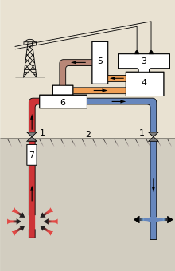[4]After the presentation of the natural principle of geothermal. It is now important to evoke the different methods which are used today to remove the geothermal energy from the Earth in the goal of produce energy.  
  
Nowadays it exists 3 process according to kind of geothermal encountered: Liquid-dominated plants, Thermal energy, enhanced geothermal  
  
All of these process are stick to the same global manipulation: The heat flux from the depths of the Earth is handled and following of this handling the heat will pulled up from the earth charged of some “calories”. These ones will be directly used as thermal energy or converted as electricity energy.  
  
However, in spite of this global manipulation, every process have its own characteristics. This is why it is important to present all of them. :  
  
 **- Liquid-dominated plants:** It is the most common type of geothermal power production in operation today. It is a technical which is used especially with very high temperature (such as more than 200°C) and in general it is operated near to young volcanoes in the Pacific Ocean and also in hot spots.  
Plants are used to generate electricity from liquid-dominated reservoirs with high water temperature.   
  
The obtaining of electricity goes through some steps:   
  
First of all, the high water (symbolized   
by the red colour on the scheme) will be   
pumped under high pressure at the surface thanks to   
some pumps (7 on the scheme).   
  
After that, the water will be sent into a heat   
exchanger (6) and this one will vaporized   
an organic working fluid that drives a turbine while  
the cooled water (in blue) is returned to the   
underground reservoir.  
It exists another process in which isobutene vapour   
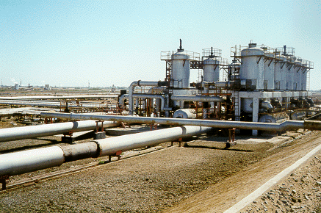and isobutene liquid are used.  
  
  
Mexico is home to the largest geothermal power plant in the world.  The Cerro Prieto Geothermal Power Station with an installed capacity of 720 MW. [5]  
  
  
  
  
  
 **- Thermal Energy:** It is a process simpler than the liquid-dominated plants. Indeed, in this technique the geothermal heat will be directly employed and converted in electricity in order to carry on lots of functions such as: electric heating essentially, seasonable thermal energy storable, air conditioning...  
How it works? Actually Hot spring water (or sometimes geysers) is directly piped into radiators. Earth tubes and heat exchangers are also extracted the heat from the Earth.   
  
Another important remark to evoke is the fact that this process is used with shallower and colder resources than traditional geothermal techniques (between 50 and 120 °C on average). Moreover, thermal energy is more cost-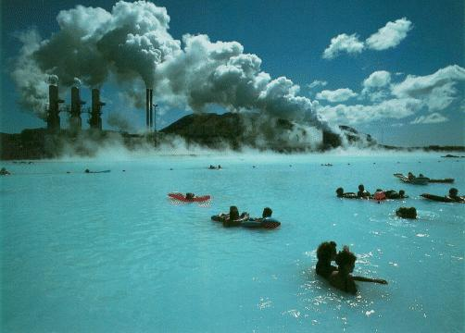[6]effective and less pollutant than heating by electricity.  
  
  
 Here a picture of Reykjavík in Iceland which is the city with the world's biggest district heating system. Actually in this city the water is piped 25km away, and can be used by residents to heating or others activities. (It is estimated that more than 93% homes are using this system on the city)   
  
The case of Reykjavik is very representative to the importance of geothermal in Iceland which is the world leader of thermal energy production (the global production by thermal energy in this country is amounted to more than 50% of the global production of energy of the country)   
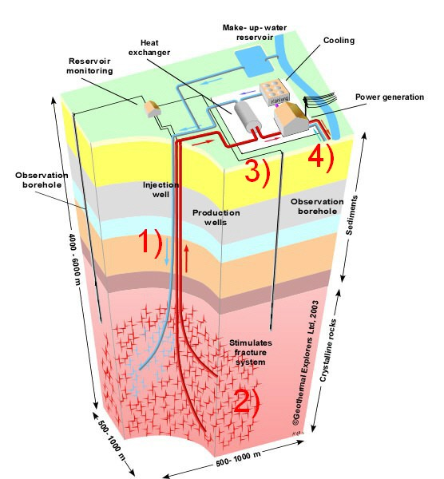[7] **- Enhanced geothermal:**Enhanced geothermal [8]is a technical in which   
 cold water is injected under pressure in order to   
extend some fissuring which were present on the   
rock (1 on the scheme). Indeed, the injection  
 increases the fluid pressure in the   
naturally fractured rock.  
  
Then, Water is travelled through fissure of the   
rock (2). Rock’s heat is caught until forced out of   
a second borehole.   
  
Finally, Electricity is created thanks to some   
devices: A steam turbine or a binary power  
plant system are used to convert the water’s  
heat into electricity. (3 and 4)  
  
Thus, enhanced geothermal permits to obtain an important quantity of geothermal electricity. However, nowadays lots of question are asked about an alleged link between the drilling which are essential for this method and the increased risk of earthquakes.   
  
Here, all of the process used to obtain energy from the earth have been presented and all of them contains significant benefits. This is what the last part of this study will analysed.

Figure 2: Electricity generation in a vapor-dominated hydrothermal system.

**Figure 3: Cerro Prieto Geothermal Power station**

**Figure 4 : geothermal in Iceland**

**Figure 5: enhanced geothermal systeme**

1. Advantages and disadvantages of geothermal energy

The advantages of geothermal energy are too important to not be considered in the 21th century wherein solutions to produce energy in quantity without polluting the Earth are always being researched.  
  
Indeed, first of all the principal advantage of geothermal energy is the **reducing of the dependence of fossil Fuels**. Geothermal energy has proved that its utilisation is clearly environmental friendly because only clean sources of energy are used. That is to say that unlike others technical (oil, nuclear…), burned fossils fuels are not used. These ones release greenhouse gases which are responsible of global warming.   
Thus the absence of pollution and the possibly to create a cleaner environment in reducing global warming represent the main advantage of using geothermal energy. Moreover, geothermal systems and gases released by their utilisation are not pollutant.  
  
Another advantage important to take into account is the **“immortality”** of this energy. Its production is constant and without any limits because the Earth will never stop to produce heat energy. So the geothermal energy is clearly a solution for the long term.  
  
The next advantage is that geothermal energy is considered **low maintenance**. Geothermal system will not require regular servicing to function properly. This is a big advantage over other systems.  
  
The **affordability** of geothermal energy is also a good point. Indeed the example of Iceland (in which more than 50% of global energy is produced by geothermal energy), highlighted that geothermal energy is cheaper and more affordable than traditional energy  
  
Finally owing to its underutilization in lots of countries geothermal energy can become a good **job provider** in the future   
  
Nonetheless in spite of these advantages , geothermal energy is not free of problems such as :  
  
**- Seismic Hazards** : because digging the Earth can be at the origin of seismic problems even if the link between them is not clearly established by scientists

**- High installation costs**: In order to get geothermal energy, very expensive installations need to be build and a certified installer and skilled staff needs to be recruited and relocated to installation’s location. Moreover, geothermal sites can stop working after long utilisation. This stopping can be due to drop of temperature or a too important injection of water in the rock. And it represents an important shortfalls for company which installed the geothermal system.  
  
**- Repartition of geothermal energy is not uniform all over the world**. Thus geothermal energy is well adapted in some regions (United States, Iceland …) in which heat is produced in large quantity and unusable in other places…  
  
**- Transportation**: Geothermal energy cannot be easily transported. It just can be used in surrounding areas after its extraction.

1. Conclusion

*This study proved that geothermal energy can be an important actor to produce the energy of tomorrow. Indeed, with it, men have the possibility to try to create an environment cleaner and safer for the future. Moreover, geothermal energy represents an excellent source of cheap, reliable, simple, clean and renewable power. Some countries have become aware of the important potential of this energy (Iceland is today the best example). However this one stay yet underused in all of the world.   
The reasons are especially, financial and demographic drawbacks and also a lack of knowledge from world population which has to be aware of this opportunity for the future.*

1. Bibliography and sources

1. http://www.geothermal.org/what.html
2. Figure 1 : Geothermal gradient’s map http://en.wikipedia.org/wiki/Binary_cycle
3. Pollack, Henry N., et.al.,Heat flow from the Earth's interior: Analysis of the global data set, Reviews of Geophysics, 31, 3 / August 1993, p. 273 doi:10.1029/93RG01249
4. Figure 2: Electricity generation in a vapour-dominated hydrothermal system. http://en.wikipedia.org/wiki/Binary_cycle  
   
5. Figure 3 : Cerro Prieto Geothermal Power station : http://gis.clas.asu.edu/EnergySources/?index.html
6. Figure 4 : Geothermal in Iceland http://www.museumofthecity.org/sustainable-practices-of-reykjavik/
7. Figure 5 : Enhanced geothermal system : http://www.hotrockenergy.com/images-of-hot-rock-energy-systems.html  
   
8. http://en.wikipedia.org/wiki/Enhanced_geothermal_system  
     
   http://www.ucsusa.org/clean_energy/our-energy-choices/renewable-energy/how-geothermal-energy-works.html#Energy_Capture  
     
   http://www.conserve-energy-future.com/Advantages_GeothermalEnergy.php  
     
   http://topdiysolarpanels.net/advantages-and-disadvantages-of-geothermal-energy/  
     
   http://en.wikipedia.org/wiki/Geothermal_energy  
     
   Geothermal Energy—Clean Power From the Earth’s Heat : By Wendell A. Duffield and John H. Sass  
   